**Step Three:**

Importing the (now) local GIT repository into **Zend Studio**

Zend only knows how to start new projects two ways:

1. Create a new one in an empty directory
2. Import a current non-Zend project into Zend

We will be taking the ‘import’ route. Trust me on this. ***DISCLAIMER: EXACT MENUS MAY VARY BASED ON YOUR VERSION OF ZEND*** – but the principles are the same in all Zend versions.

Press the ‘File’ menu button and select the ‘Import’ option:

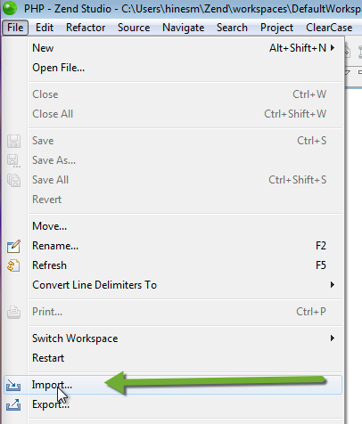

You will want to import a ‘Project from Git’:

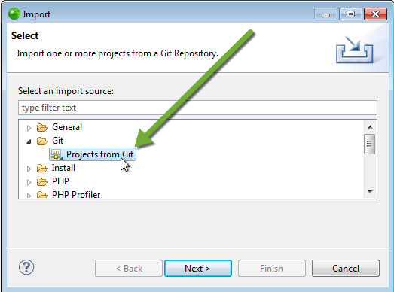

You will be using your local copy of GIT on your PC/VDI, so pick ‘Local’:

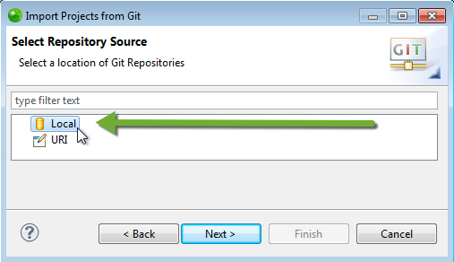

If you don’t see it the list (or the list is empty), press the ‘Add’ button:

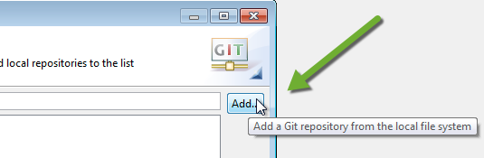

And then track down the directory where your local GIT repository is stored:

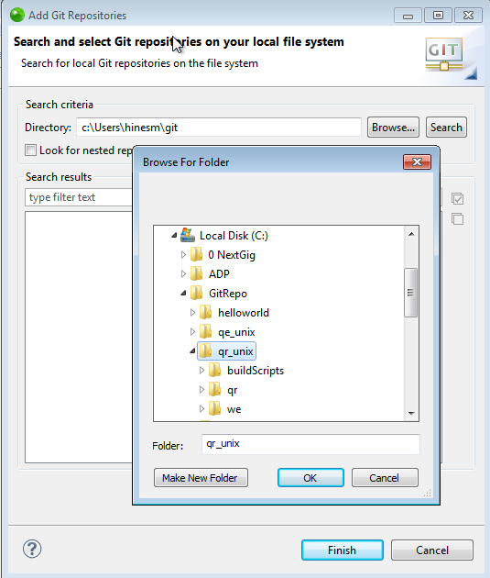

You will have to select your local repository from a list:

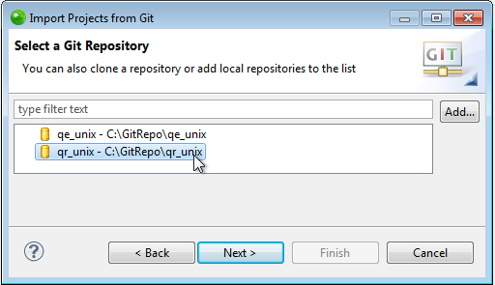

Select the correct repository and press ‘Next’

Now we tell Zend to import this as a ‘general project’.

We normally only want one directory of a unix project duplicated on our Zend dev port (it is the ‘qr’ directory in the example below). We have to tell Zend about this now as well.

Open the ‘Working Directory’ to see the child directories and select the one you need:

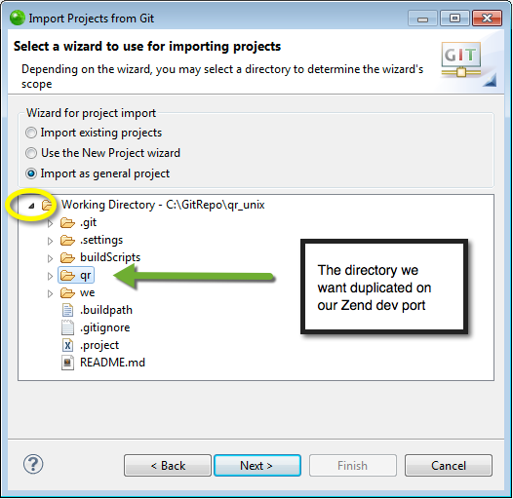

We can change the name if we want to (or not). Press ‘Finish’ when you are ready:

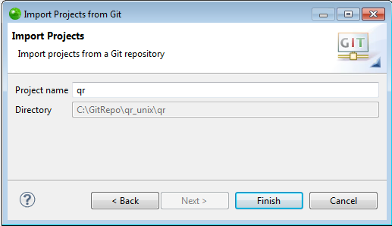

Here is how the imported GIT project now looks in Zend’s PHP explorer:



*OK then: Step three is done.*